EXISTING PAGE MODIFICATIONS

Pi Creation

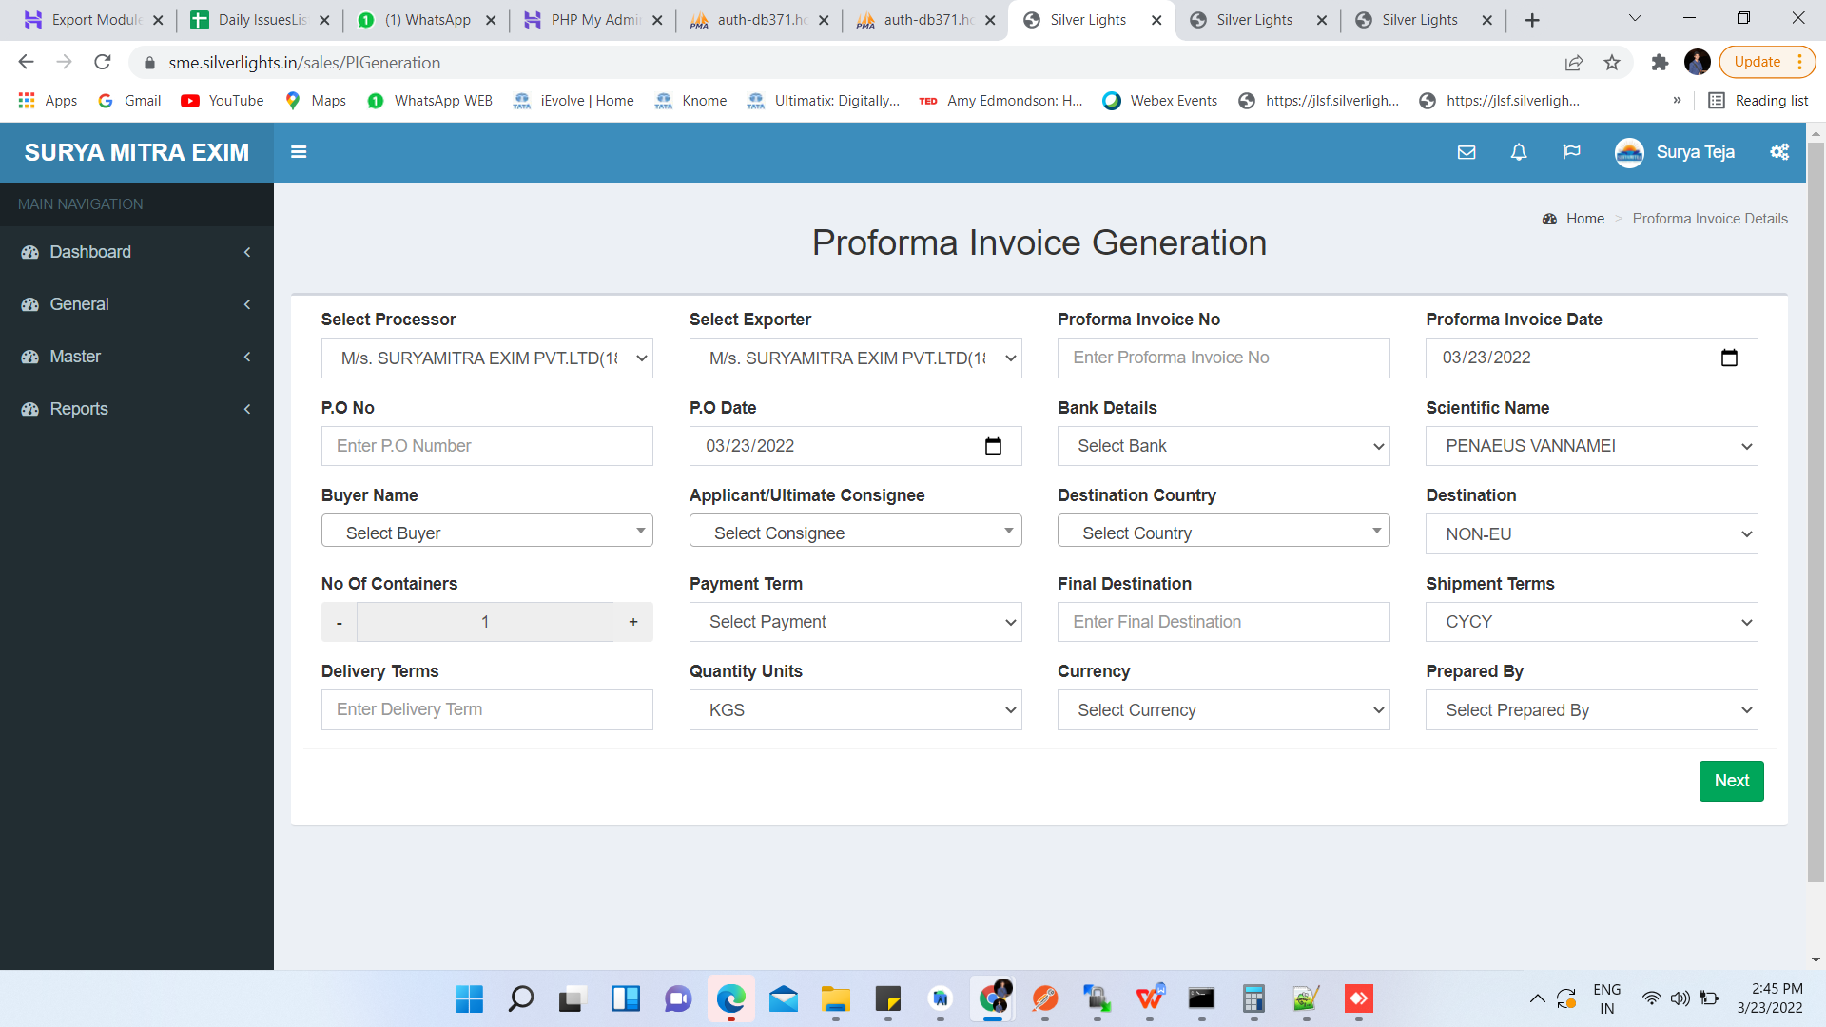

Change Header > Proforma Invoice Generation > New Proforma Invoice

Remove > Destination > Destination

Order > Destination Country,Final Destination

Buyer Creation

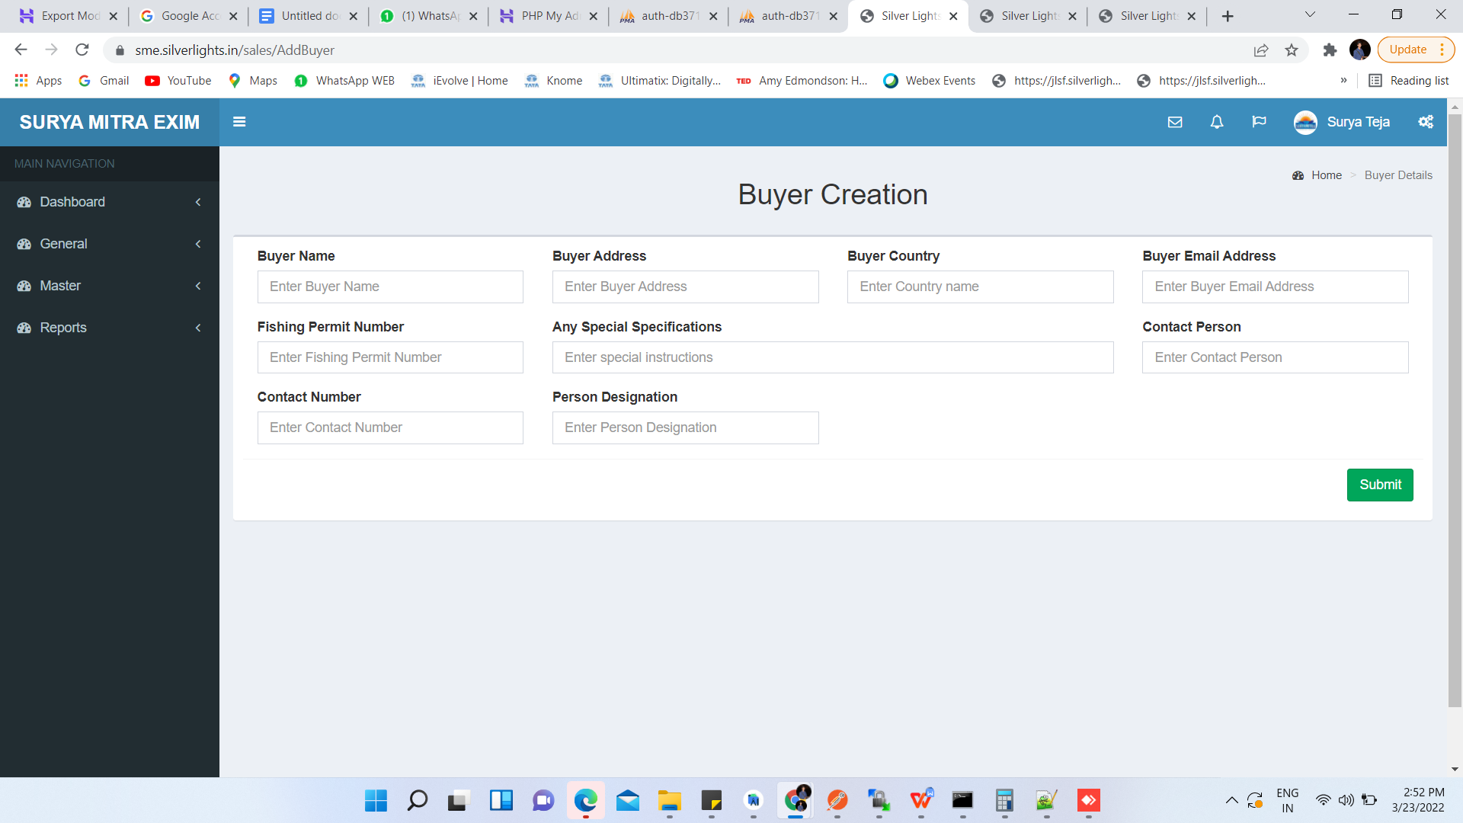

A)Change Header > Buyer Creation > New Buyer
B)Remove > Fishing Permit Number,Any Special Specifications
C)Multiple Mail Ids Separate With Comma To Be Maintained In Masters

Applicant Creation

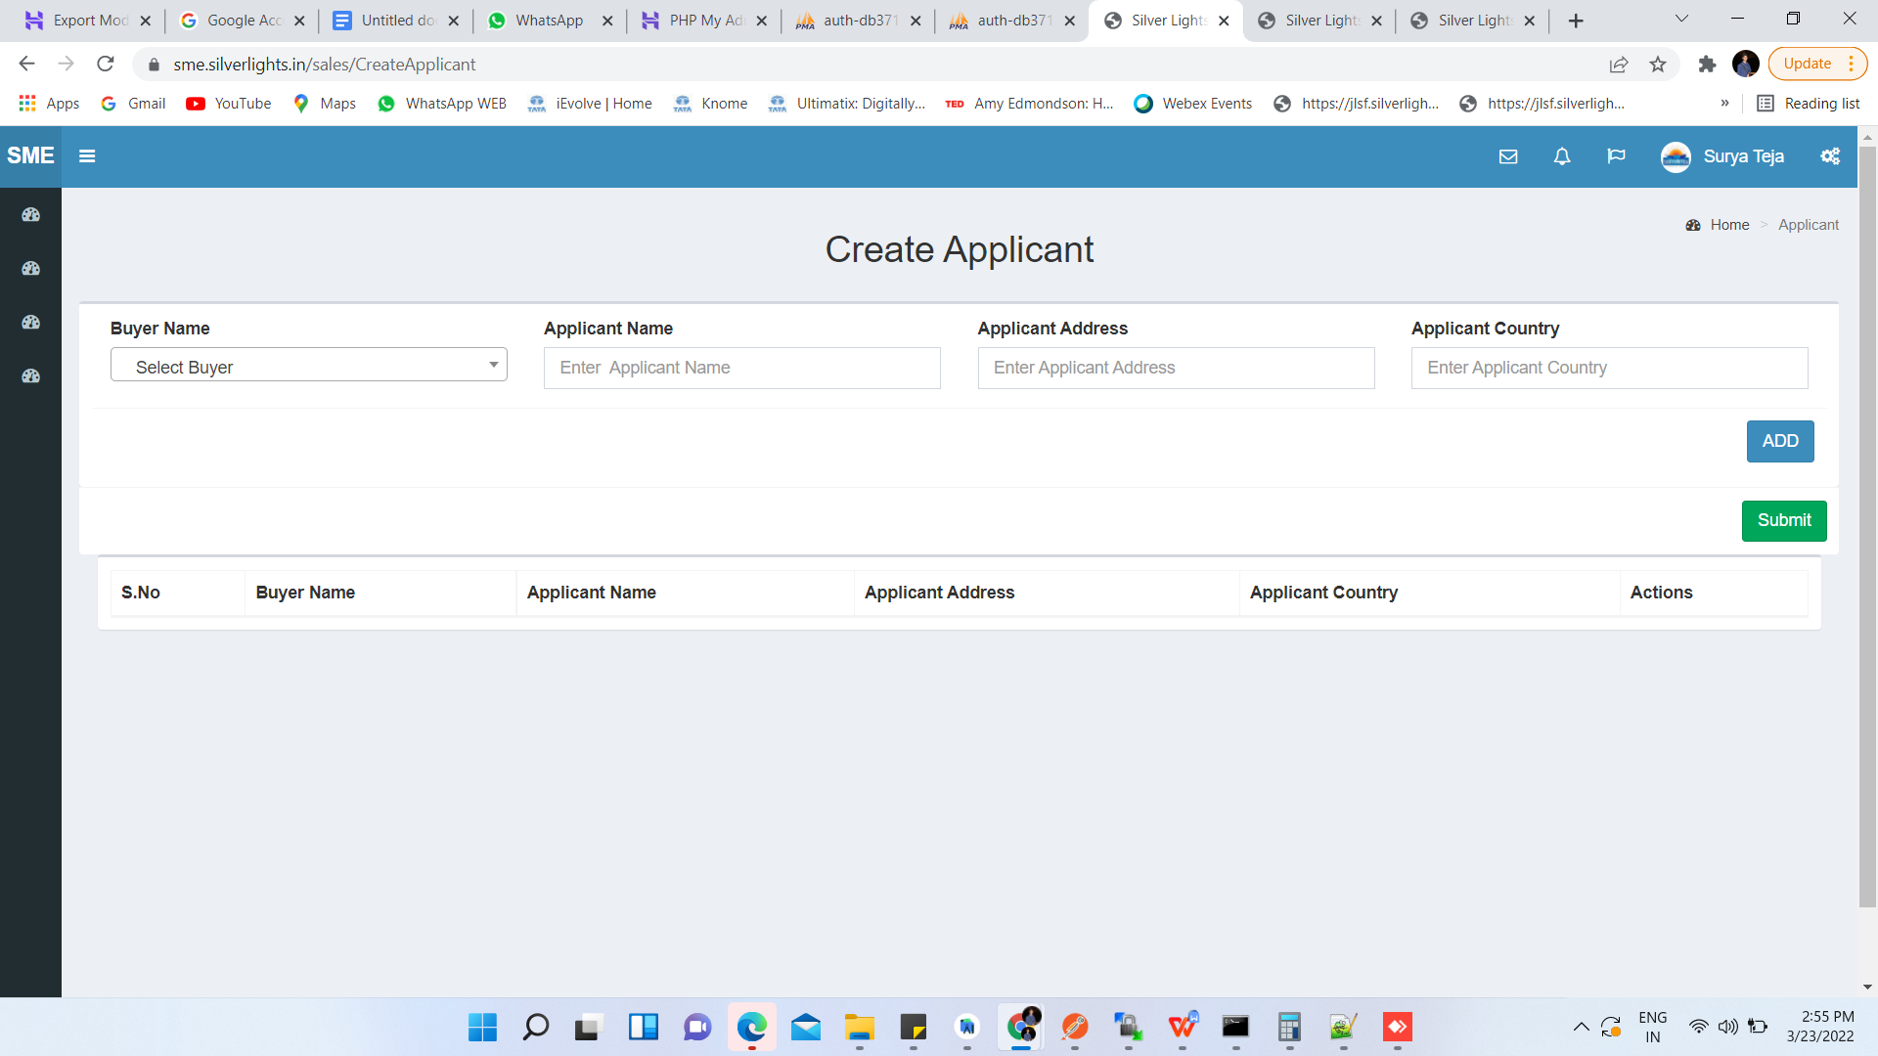

- Change Header > Create Applicant > New Applicant
B) Applicant Country > Drop Down

Applicant Creation

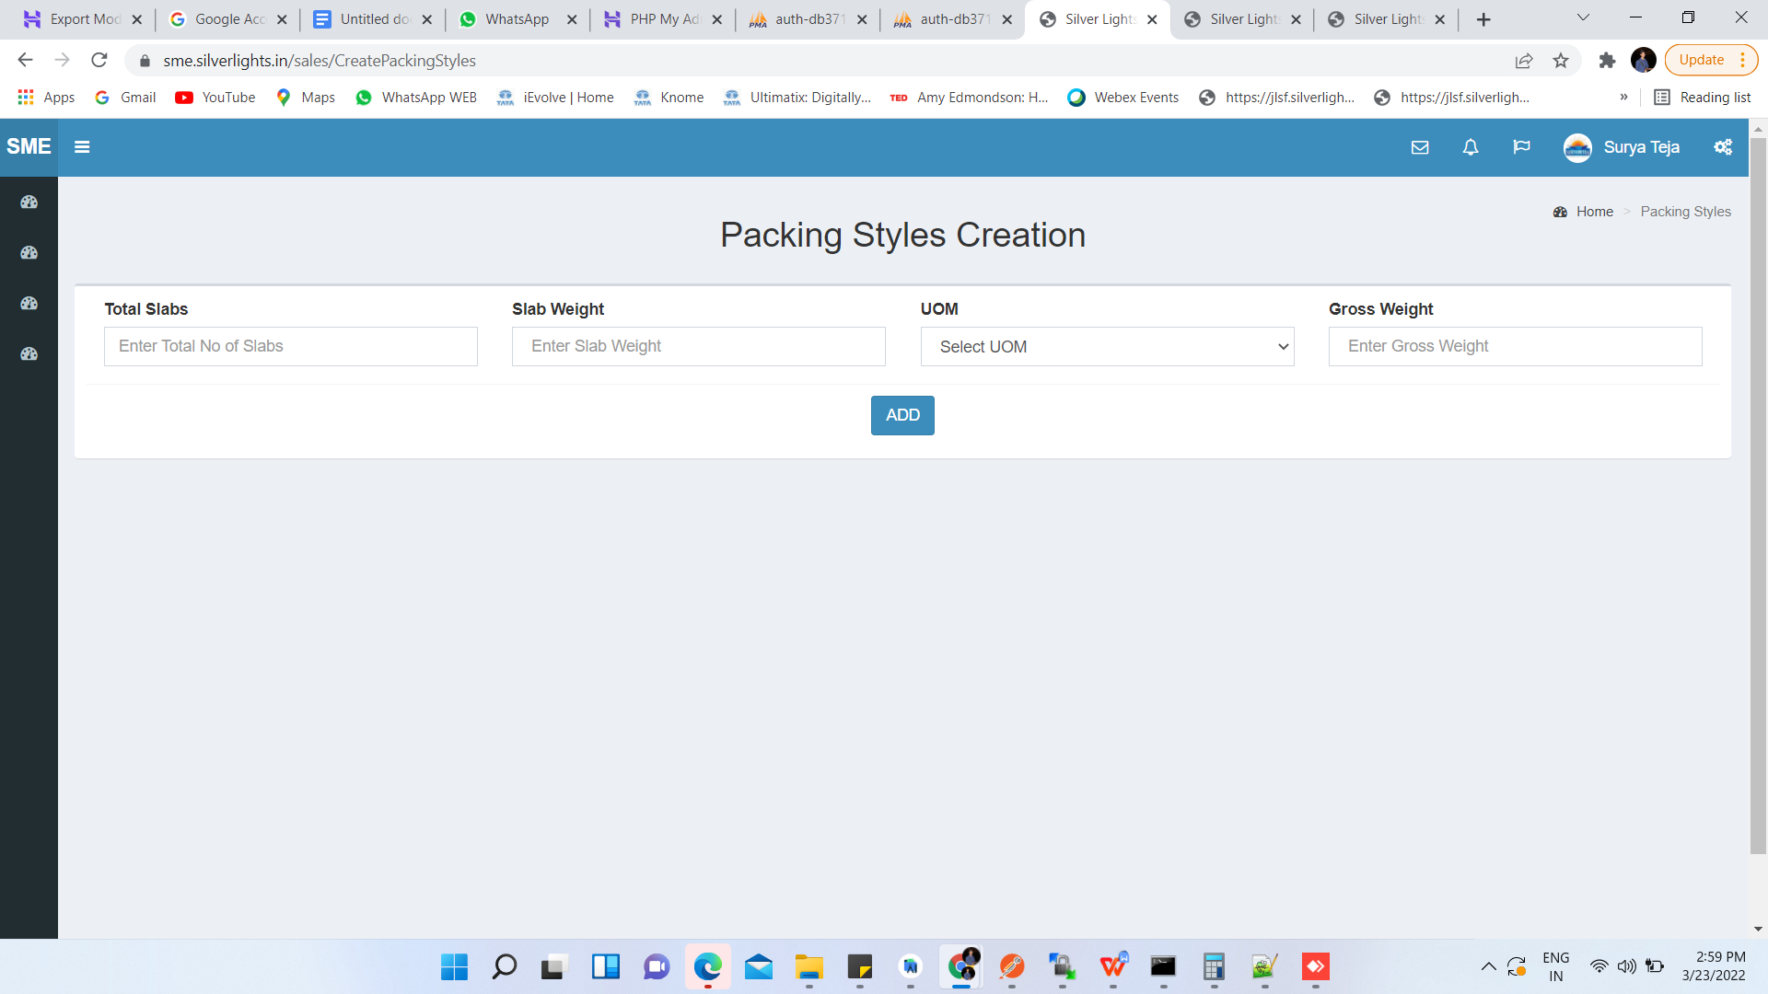

- Change Header > Packing Style Creation > New Packing Style

Payment Terms

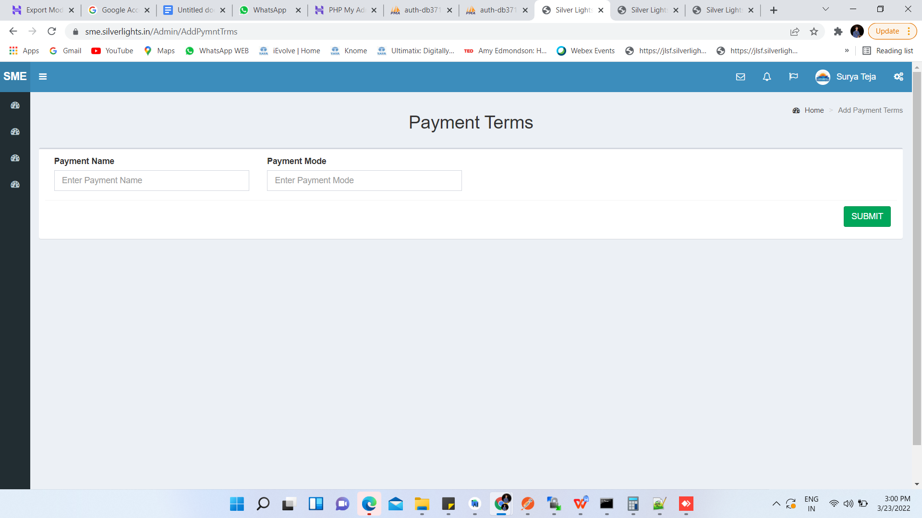

- Change Header > Payment Terms > New Payment Term
- Payment Mode > Drop Down > LC , Non LC

CHA CREATION

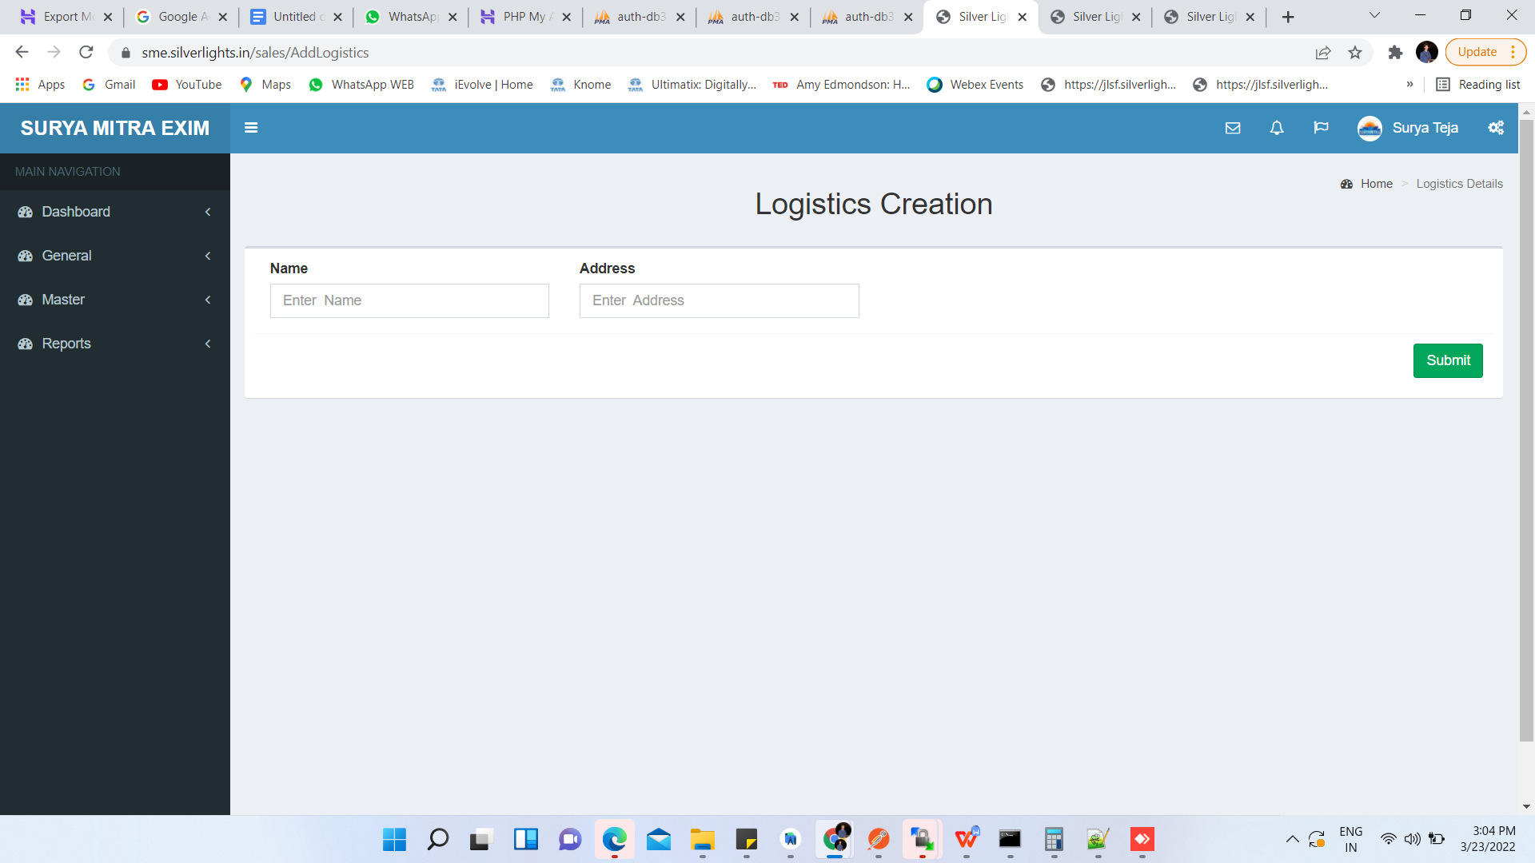

- Change Header > Logistics Creation > New CHA Agent
- New Fileds > Contact -Sales, Mail Id -Sales,Address -Sales ,City -Sales
Contact -Operation, Mail Id -Operation,Address -Operation,City -Operation
Contact -Booking, Mail Id -Booking,Address -Booking,City -Booking
Contact -Docs, Mail Id -Docs,Address -Docs,City -Docs

Proforma Invoice List

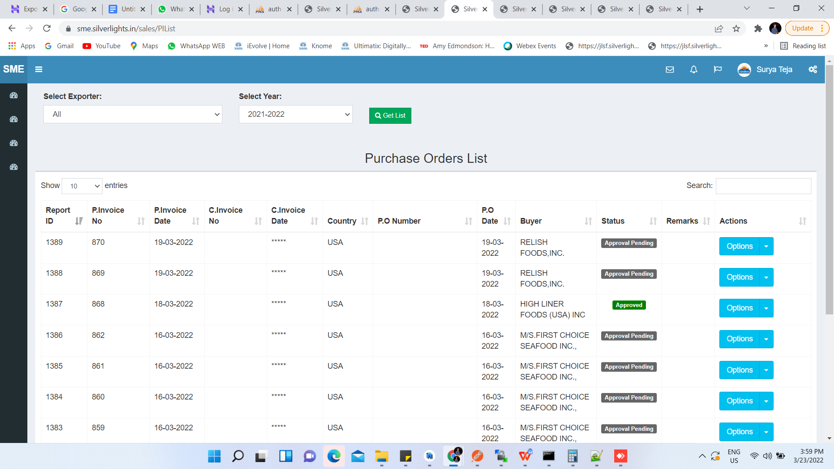

A)Remove Options > Show Icons > Add ,Edit,view(+ Icon , Edit Icon,Eye Icon)
B)Add> Navigates To> Add page Like Qc > There User Can Create Documents(List Given)
C)Max 8 Fields per Page apart from Actions >Get List From Ratnagiri @Lokesh
D)Change Header > Purchase Order List > Proforma Invoice List

NEW PAGE

- Linear Master

- Fields > Linear Name ,Linear Address,Contact No ,Alternate Contact No,Email Id,
Container Tracking Url

- Bank Master

- Fields > Bank Name,Bank Address,Contact No,e-mail ID,Branch Code, City

- Shipment Status Details -> Po Attachment
- Actual Shipment Date,ETA,Payment Request Date,Bank Payment Date,FDA Release Date,FDA Release Status

REPORTS

A)FBD format
B) Export information Report
C) Head-on Format ( linked with shipment planning sizes)
D) Running orders format
F)Bill of Exchange format

